**Hong Kong-International Food Week**

1. ***Introduction***

We are the owners of a growing food company called International Food Company. Our company sell international food products in China and Hong Kong. Our products are very diverse, we import from many countries from Europe (mainly Italy,France,Hungary) and also other Asian countries (Japan, Vietnam). We import some products from Mexico as well. For example we sell spices, handmade pasta and everything which is typical in the international cuisine.

As the owners of the International Food Company we would like to organise an international food week in Hong Kong in order to promote our company’s products. This event would be on the street, where people could try different food. We would cook every day something different, which is a traditional dish in other countries. The event would last 1 week and visitors could buy our products as well.

For the international food week we are looking for a place, where there are lot of restaurants which are not typical Chinese restaurants. This restaurants could be our main target and people who go there, becasue they like international food. So we are looking for a neighborhood in Hong Kong, where the restaurants are interantional diverse.

1. ***Data***

For this business problem, we used first Hong Kong location data. For that, we used wikipedia to get the latitude and longitude values for the neighborhoods in Hong Kong. (It is not shown in the code.) In Hong Kong there are 9 districts with 60 neighborhood.

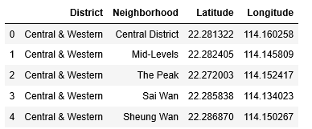

After that we used Foursquare location data for Hong Kong and its restaurants. From Foursquare we got all of the nearby venues for the neighborhoods.

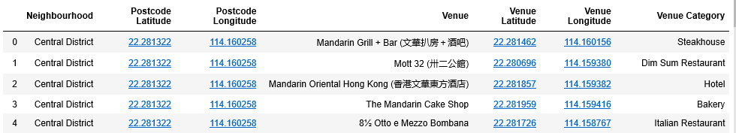

1. ***Methodology***

From the dataseta above we filtered venues which included the word „restaurant” in order to find only the restaurants. After that we divided the restaurants into 7 category:

1:North America  
2: South America  
3: Asia, but not China  
4: Australia  
5: Europe  
6: China  
7: others (for example Vegan)

We counted the number of the restaurants in each category. From these results we made clusters for categorizing the restaurants. We used K-means clustering for that. We tried with different number of clusters. It looked that with 3 clusters we can find the main differences between the clusters. From the 3 clusters we choose the most diversified one. We could choose the most appropriate neighborhood later, after examining more qualitative and quantitave methods. Our purpose with the neighborhood clustering is simply understaning the main differences and characteristics between the neighborhood.

1. ***Results***

We got 3 clusters. In the first cluster there are only 6 neighborhood with the most diversified restaurants. In these areas most of the restaurants are Asian, but not Chinese (category 3) The second most often are Chinese restaurants (category 6) and there are some European (category 5) or other type of restaurants (for example Vegan). Restaurants from other part of the world are rare in this cluster.

**Cluster 1:**

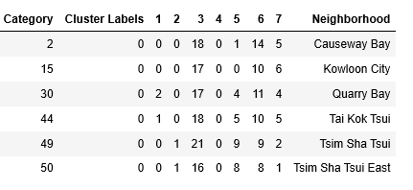

The second cluster is the largest with 36 neighborhoods. In these neighborhoods the restaurants are very rare.

**Cluster 2:**

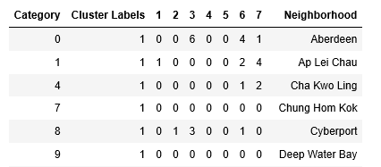

In the third cluster there are 17 neighborhoods with larger number of restaurants. These restaurants are mainly Chinese one.

**Cluster 3:**

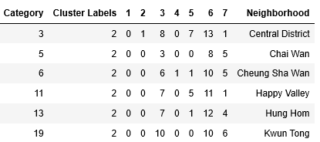

We can clearly see from the clusters, that the first cluster is the most internationally diversified. This is the cluster, which we were looking for.

1. ***Discussion***

As we could see, the first cluster is the most diversified, but other continents like Europe or America are very rare in these restaurants. People from Hong Kong tend to like more other Asian food for example Vietnamese or Japanese.

1. ***Conclusion***

The international food week could take place in one of the neighborhoods in the first cluster. Because Asian food is more popular than the other countries, the main focus on the restaurant week could be the other Asian countries. European and other type of food could have smaller role. That means, we will try to sell more Japanese, Vietnamese products.

In the firts cluster there are 6 neighborhood. We need to examine further with quantitave and qualititave methods where exactly this event could take place. For that we need to count possible revenues and costs and check empty spaces where we could put up our tents.